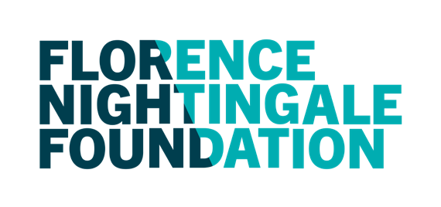

Sarah Holbrook

Sarah Holbrook is part of the 2021 FNF Emerging Leader Scholarship cohort and during her scholarship year she was a Team Lead with the Integrated Discharge Service at North Bristol NHS Trust.

Sarah had worked for the best part of 15 years in the organisation as a registered nurse in various roles including some junior leadership experience in addition to 2 years in the community as part of an end of life service.

In September last year Sarah moved to Guildford in Surrey to commence a role as Lead Nurse for Patient Flow at Royal Surrey NHS Foundation Trust. This has been an exciting opportunity to have further influence on the management and service development of complex discharge programme and making a difference to patient experience and outcomes.

Sarah is in the process of setting up a network of like-minded discharge leads across the local area to share challenges and good practice and support each other with local knowledge of service provision and development of expertise, all this as a result of her scholarship journey.

The next step for Sarah is the commencement of a new leadership programme with another organisation to support in the development of her current role and network and the future leadership journey and life story.

10-18 Union Street London SE1 1SZ United Kingdom

020 7730 3030
info@florence-nightingale-foundation.org.uk Florence-nightingale-foundation.org.uk

Registered in England & Wales Charity Reg. No. 229229 Registered in Scotland Charity Reg. No. SCO44341
A company Limited by Guarantee Registration No. 00518623

