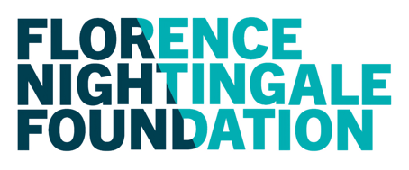
NOMINATOR FORM – SENIOR SPONSOR APPROVAL
Applications without this form will not be considered for the respective programme.
Fields marked with an * are required
IMPORTANT INFORMATION
This form is part of the application process and must be completed by a senior sponsor within your organisation who can support your full participation in this programme.
Forms must be filled out electronically and renamed prior to upload to include your professional registration number and name e.g. 'Nominator form - John Smith 12345'.
Programme name: *
Name of applicant: *
SENIOR SPONSOR DETAILS
First Name: *
Last Name: *
Email: *
Email confirmation: *
Finance Department Contact *
Finance Department Email *
Job Title: *
NHS Trust / Organisation: *
Relationship to applicant: *
Signature: *
Date: *

The Florence Nightingale Foundation will hold your details to process your employee’s application and to keep you up to date on what’s happening at the Foundation. If you prefer not to hear from us you can unsubscribe from all further communications at any time by emailing academy@florence-nightingale-foundation.org.uk.

